Supply List for Pre-K
Welcome to Pre-K. Here is a list of items your child will need for a fantastic school year!
~ 1 Regular Size Backpack large enough to fit a folder (without bending it) and your child’s blanket and sheet
~ 1 Regular Size Lunchbox
~ 2 Plastic Folders
~ 2 packs of Crayola 24 count crayons
~ 2 packs of 16 Triangular Crayola Crayons
~ 1 pack of Crayola 10 count Washable Markers
~ 1 pair of Fiskars Scissors
~ 8 Regular size cans of Play Doh (any color will be greatly appreciated)
~ 1 pack of Elmer’s 3count Giant Washable Glue Sticks
~ 1 bottle of Elmer’s School Glue (No Glitter Glue)
~2 packages of baby wipes
~ 3 rolls of paper towels
~ 3 box of tissues
~ 2 containers of Lysol/Clorox disinfecting wipes
~ 1 Full change of clothes (in case of spills/accidents) in an extra- large Ziploc bag labeled. Please include 2 shirts, 2 pairs of pants, 2 pairs of socks, 2 pairs of underwear, 1 pair of shoes

~ 1 fitted crib/toddler sheet to cover mat for rest time. Please label (Full Day children only)
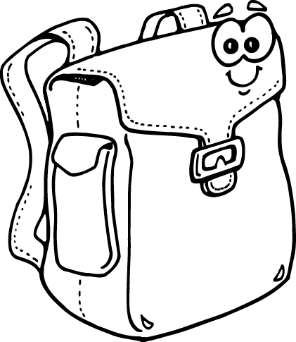
~ 1 blanket for rest time. Please label (Full Day children only)
Please sign up for any additional supplies on Orientation Day!
Thank you!

